**COVID Vaccines Analysis**

**Project Definition**

The problem is to conduct an in-depth analysis of Covid-19 vaccine data, focusing on vaccine efficacy, distribution, and adverse effects. The goal is to provide insights that aid policymakers and health organizations in optimizing vaccine deployment strategies. This project involves data collection, data preprocessing, exploratory data analysis, statistical analysis, and visualization.

**Problem Statement**

* Which country is using what vaccine?
* In which country the vaccination programme is more advanced?
* Where are vaccinated more people per day? But in terms of percent from entire population ?

**Design Thinking:**

**Step 1**

Data Collection

Dataset for my project “COVID Vaccines Analysis” was successfully collected .

The Dataset for my project was download from the website named “Kaggle”.

**Step 2**

Data Preprocessing

In that some of the columns contained null values I have replaced the null values by 0 with the use of replace functions and started working on the data.

**Step 3**

Exploratory Data Analysis(EDA)

After loading the data and after analyzing the data | understood that there are 86512 rows and 15 columns. **By** Explore the data I can understand its characteristics, identify trends, and outliers.

**Step 4**

Statistical Analysis, Visualization, Insights

**1. Which country is using what vaccine?**

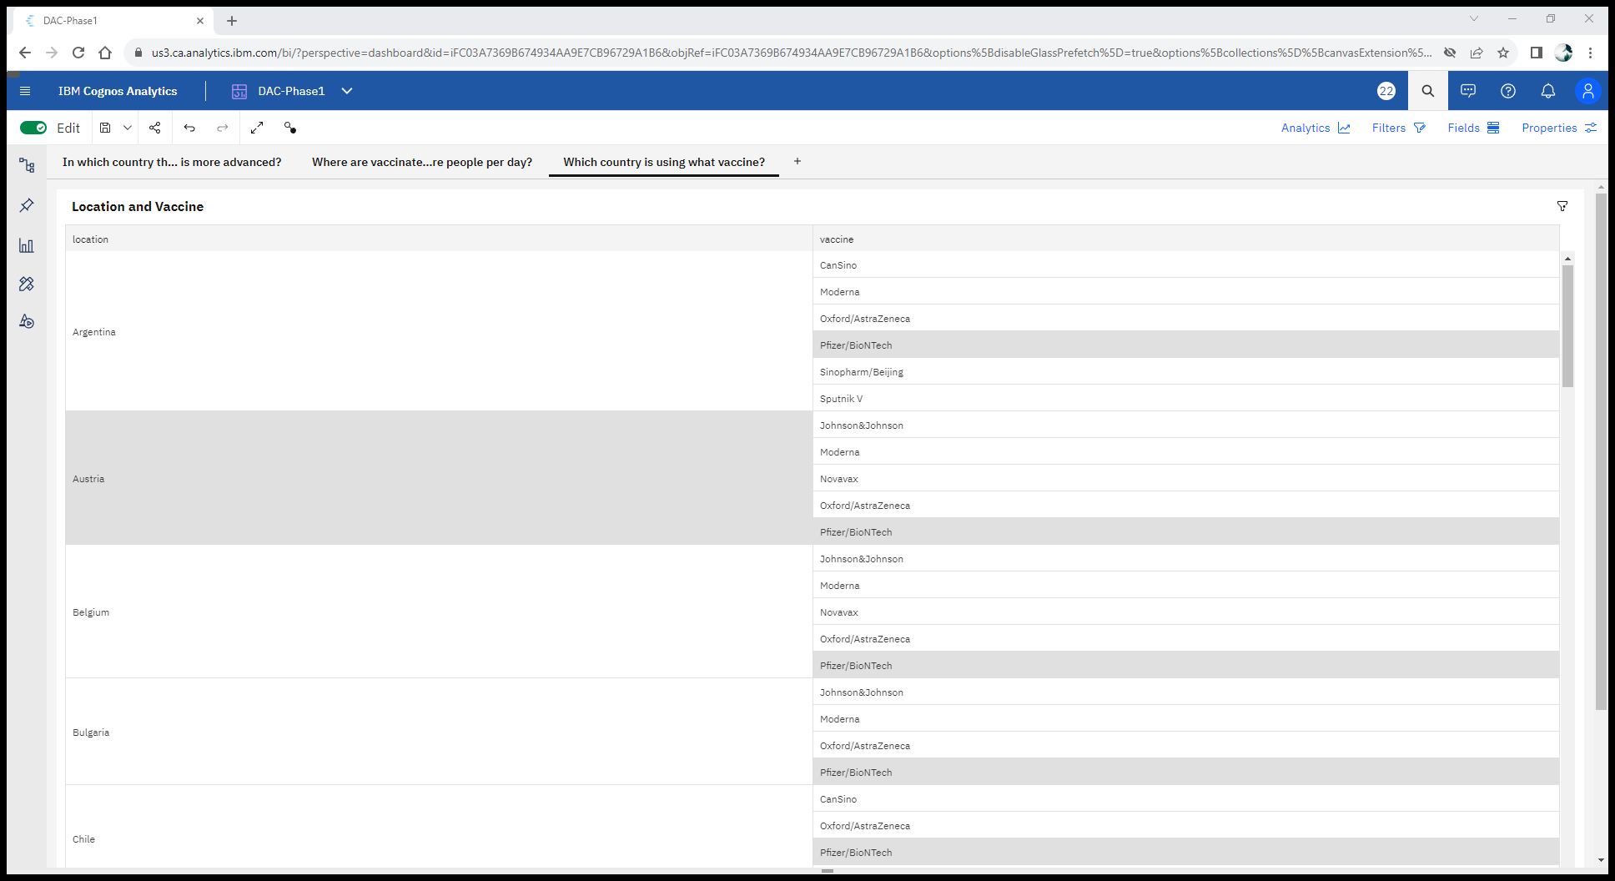

From the above image we can able to know that information of vaccine used by their countries . Through this dashboard we can able to see what are the vaccines used by the countries These are the vaccines used by the countries

* Moderna
* Oxford/AstraZeneca
* Sinopharm/Beijing
* Sputnik V
* CanSino
* Pfizer/BioNTech
* Novavax
* Covaxin
* Johnson &Johnson

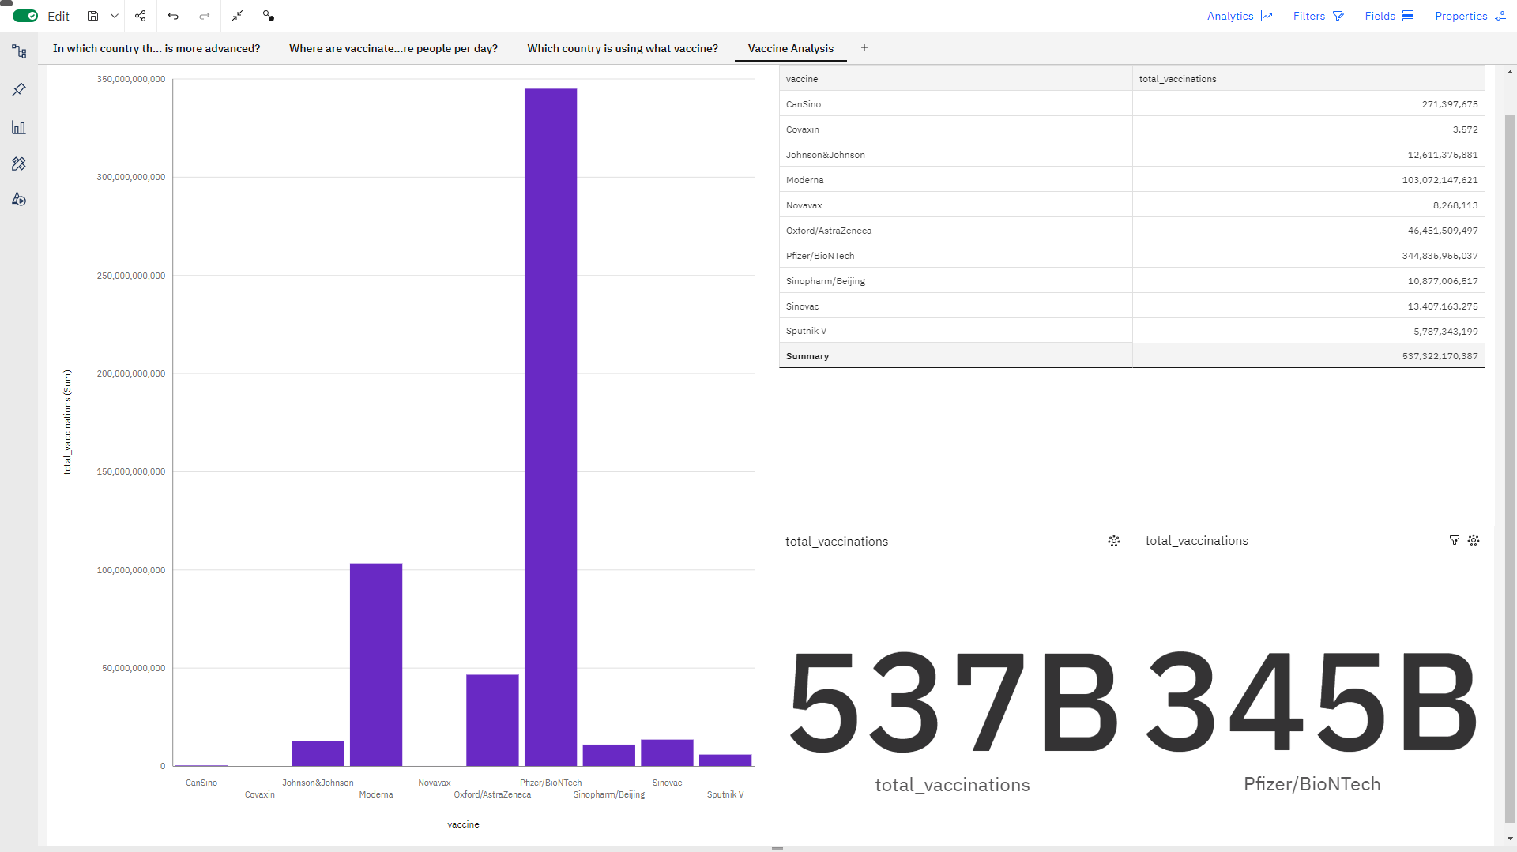

**INSIGHTS**

* **Total vaccinations** is unusually high when **vaccine** is **Pfizer/BioNTech**.
* Over all **vaccines**, the sum of **total vaccinations** is **approximately 537 billion**.
* The overall number of Pfizer/BioNTech for **total vaccinations** is **nearly nine thousand**.

2. In which country the vaccination programme is more advanced?

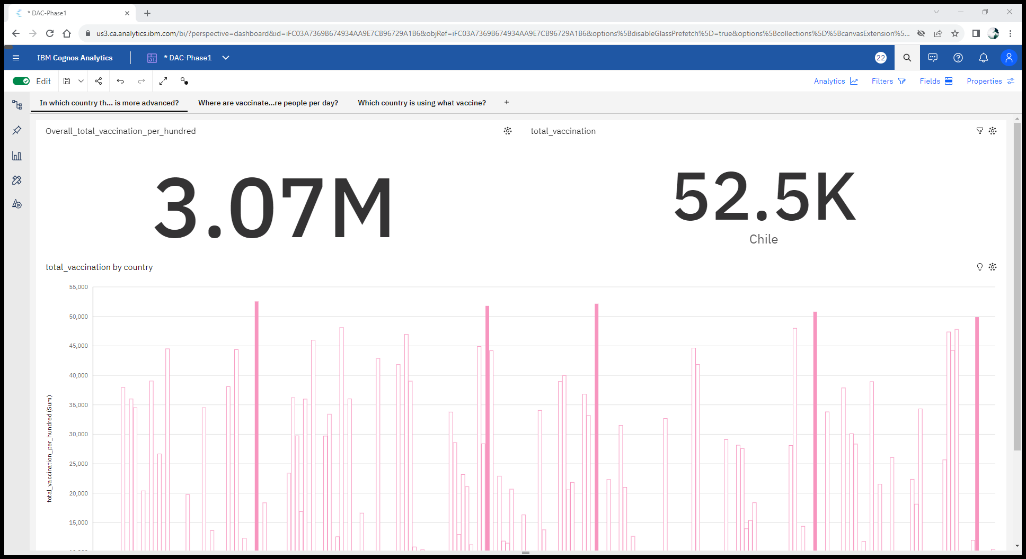

From the above image we can able to see that the overall count of total vaccination all over the countries is about 3.07M per hundred in the overall vaccination the country **“Chile”** made a total vaccination of 52.K per hundred vaccination . It was the reason to make the country in more advance in vaccination program .Followed to the Chile there are some other countries which close to it. And they are “Israel”, ”Malta”, ”Singapore:. Through this dashboard we can able to see the how the vaccination program was ongoing in the countries.

**INSIGHTS**

* **Total vaccination per hundred** is unusually high in **Chile, Malta, Israel, Singapore** and **Wales**.
* Over all **countries**, the sum of **total vaccination per hundred** is **nearly 3.1 million**.
* For **total vaccination per hundred**, the most significant values of **country** are **Chile**, **Malta**, **Israel**, **Singapore**, and **Wales**, whose respective **total vaccination per hundred** values add up to **nearly 257 thousand**, or **8.4** % of the total.
* Where are vaccinated more people per day? But in terms of percent from entire population ?

**Where are vaccinated more people per day? But in terms of percent from entire population ?**

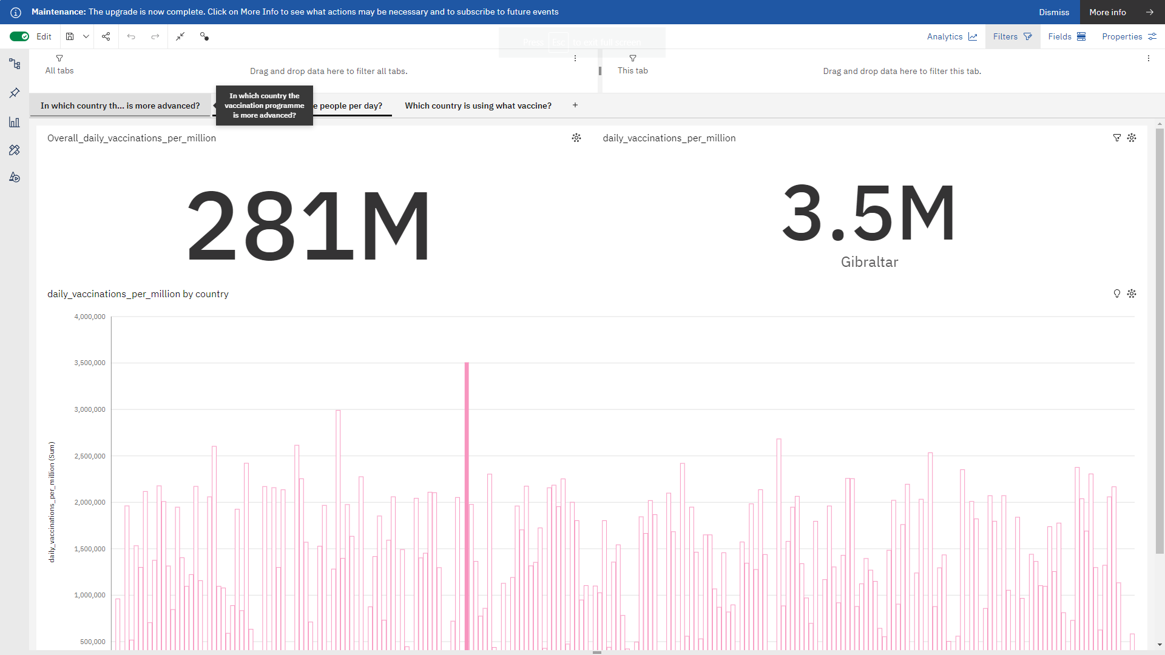

From the above image we can see that the per day vaccination is higher in the country **“Gibraltar”** which have made **3.5M** per **million**  in a single day. Which is highest among all other countries. The overall one day vaccination done by all the countries is 281M per million.

**INSIGHTS**

**•** Daily vaccinations per million is unusually high in Gibraltar.

• **Daily vaccinations per million** has most unusual values at **10** time points, the most notable of which are **2021-02-27**, **2021-03-13**, **2021-03-09**, **2021-02-20**, and **2021-11-20**.

• Daily vaccinations per million ranges from 988, in Burundi, to over 3.5 million, in Gibraltar

• Based on the current forecasting, daily vaccinations per million may reach nearly eight thousand by date 2022-06-20.